INSTRUCTION PAGE i

Following is a template letter that can be used in the situation where a health service refuses you access or treats you differently because of your face mask exemption. This can be used if you are a patient or a visitor.

If you have been forwarded this letter by a friend, family member or colleague, then please go to https://voicesforfreedom.co.nz/resources to see more information regarding applying for a face mask exemption certificate, or other mask-related letters more specific to your situation.

Disclaimer: It is a strict condition of reading and/or using this letter in any way you irrevocably agree that you are bound by the terms and conditions of this disclaimer. If you do not agree with the terms and conditions of this disclaimer, you are prohibited for reading and/or using this letter. Notwithstanding anything in this letter, the information set out in this letter is for general information only, and should not be construed as legal advice and/or health advice. No client-solicitor relationship is created whatsoever. Before taking any action based on this letter, you should consider your personal situation and seek professional legal advice. You acknowledge and agree that you were advised to take legal advice prior to using any information in this letter. If you use this letter and/or any information in the letter you acknowledge and agree that you have relied on your own judgement and initiative and not in reliance of anything else. The reader and/or user of this letter agrees to protect, indemnify, defend, and save harmless the author absolutely from and against any and all damages, claims, losses, demands, liabilities (including vicarious liability), injuries, suits, actions, judgements, costs, and expenses of any kind whatsoever (including reasonable legal fees) arising out of or in any way connected with this letter and the information contained within. Any person and/or persons that shares this letter without this disclaimer accepts full liability for any damage whatsoever caused.

If you are sharing this document with others, you acknowledge and agree that you are prohibited from removing this disclaimer. The disclaimer may only be removed once the letter is ready to be sent by the person sending it. You are also prohibited from amending the letter other than the sections identified for you to add to and you acknowledge and agree to this. If, however, you would like to use parts of this letter in a letter that you draft yourself then you are permitted to do so.
INSTRUCTION PAGE ii

WHAT IS THIS LETTER FOR?

Following is a proposed template letter you may consider sending to a health service that has refused you access to their premises or treats you differently because they do not accept your exemption from wearing a face mask. This letter is for a patient or a visitor to the health premises.

New Zealand dropped the Traffic Light settings in mid-September 2022 and brought in a new order specific to masks, namely COVID-19 Public Health Response (Masks) Order 2022 (Mask Order).

All of the orders change regularly - for the latest orders see the following for the latest, current orders: https://covid19.govt.nz/about-our-covid-19-response/legislation-and-key-documents/

Under the Mask Order, masks are to be worn at certain health service premises if you are a visitor, support person or contractor, unless you have an exemption. Masks do not have to be worn if you are a patient, worker or have a valid exemption, or are at a premises cited in the Mask Order as being exempt from the Mask Order.

The Mask Order trumps any policy of a health service – ie the health service’s policy is secondary to the law. However, be careful and pick your battles. A lot of health services think they are above the law and if you need treatment – then undertake your own risk benefit analysis and send this letter to management and make a complaint to the Health and Disability Commissioner after the fact.

What is and is not a health service for the purposes of the Mask Order?

For the purposes of this letter, the Mask Order provides that a health service includes premises where:
- services are provided for the purpose of assessing, improving, protecting, or managing the physical or mental health of individuals or groups of individuals – and includes a general practice or medical centre;
- treatment or social rehabilitation is provided under the Accident Compensation Act 2001:
- disability support services within the meaning of section 4 of the Pae Ora (Healthy Futures) Act 2022 are provided.

Locations where a mask needs to be worn (unless you’re a patient, worker or have an exemption) include:
- doctors' clinics
- community and iwi health providers
- pharmacies — but not those inside supermarkets
- hospitals
- urgent care services, such as after-hours clinics
- disability support services
- residential care for older people and people with disabilities
- diagnostic services such as blood testing or radiology services
- dentists and oral health services
- other health services such as optometrists, physiotherapists, or chiropractors.

The Mask Order specifically excludes the following from a health service, meaning you do not need to wear a mask at any of the following locations that provide health service:
- receiving residential care at the premises;
- a psychotherapy or counselling service;
- a mental health service:
- an addiction service.

What is a mask?

A “mask” does not mean a specific type of mask or a medical mask. Mask is defined in clause 3 of the Mask Order:

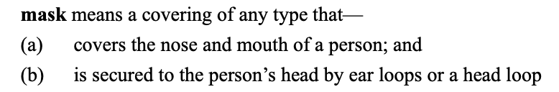

What are the exemptions from wearing a mask at a health service?

Exemptions from wearing a mask at a health care service come about in one of four ways:

- you are a patient or a worker at a health service – clause 5 of the Mask Order expressly states you do not need to wear a mask;
- you have a disability or condition that makes it unsuitable for you to wear a mask – clause 6(1)(a)(ii) and 6(2) of the Mask Order expressly provides that you do not need to wear a mask;
- you have a personalised mask exemption which you have received from the Ministry of Health – clause 7 and 8 of the Mask Order.
- the premises you are at are providing health services is excluded by the Mask Order (see bottom of page 3 above).

We expand on each of the above immediately below, under their own heading.

In all instances, the above exemptions from wearing a mask should be respected by a health service. However, many health services are not cognisant of the Mask Order and think their policies override the Mask Order – they do not.

This information and letter is designed to provide you the information you need to have a conversation about these issues. However, if there is push back and medical care is refused, then you need to weigh the risk/benefit analysis of being seen versus proving a point. You can always raise the issue afterwards with management and the Health and Disability Commissioner.

1. Patient or a worker

Clause 5 of the Mask Order expressly states you do not need to wear a mask if you are an employee or patient at a health services or a resident at a residential care facility. See clause5 of the Mask Order.

2. Disability or condition making it unsuitable for you to wear a mask

Grounds and circumstances that give rise to an exemption from wearing a mask are set out in clause 6 of the Mask Order, and repeated at paragraph 5 of the template letter below. The likely main ground for an exemption will be that you have a condition or disability making it unsafe, difficult or not possible for you to wear a face mask.

Condition/s are not defined, but a non-exhaustive list of conditions that people have found make wearing a mask unsuitable includes:
- shortness of breath  - asthma  - bronchitis | - pregnancy  - feelings of anxiety  - deafness | - PTSD  - facial hair  - skin irritation

Disability is defined in section 21(1)(h) of the Human Rights Act 1993.defined as:
- physical disability or impairment:
- physical illness:
- psychiatric illness:
- intellectual or psychological disability or impairment:
- any other loss or abnormality of psychological, physiological, or anatomical structure or function:
- reliance on a guide dog, wheelchair, or other remedial means:
- the presence in the body of organisms capable of causing illness:

You should not feel bad because you cannot wear a mask. If you have a reason for not doing so, then as per the exemptions, you should feel comfortable in your position.

3. Personalised Mask Exemption

From the beginning of June 2022, the MOH brought in a personalised mask exemption called a “mask exemption pass” – this pass is recognised at clause 8 and 9 of the Mask Order.

The “personalised” mask exemption pass provides conclusive evidence that the holder is exempt under law from wearing a face mask. Because this pass is recognised in law, people are encouraged to apply for a personalised mask exemption pass. For further details, and how to apply see: https://covid19.govt.nz/prepare-and-stay-safe/protect-yourself-and-others-from-covid-19/face-masks/advice-for-people-who-have-difficulties-wearing-a-face-mask/

While it is inappropriate for a health service worker or employee to enquire about the nature of a person’s disability or condition, it is reasonable for them to ask whether a person has an exemption from face mask requirements.

If a health service worker or employee refuses you entry for not wearing a mask, this may be discrimination on the ground of disability, and you could make a complaint to the Human Rights Commission and/or Health and Disability Commissioner. People with a mask exemption should be granted access to the same health services as people who can wear a mask.

Some businesses or services, such as GP practices may require people who aren’t wearing masks to access their business or service via a different entry process or location. However, this appears to be at odds with clause 5 of the Mask Order, which expressly states that the following people don’t need to wear a mask when at a health service premises:

(a) the person is a patient or worker of the health service; or
(b) the person is receiving residential care at the premises; or
(c) the health service provided at the premises is 1 or more of the following:
(i) a psychotherapy or counselling service:
(ii) a mental health service:
(iii) an addiction service.

4. Certain locations providing health services do not require masks to be worn

See the list at the bottom of page 3 above.

What are my rights?

It is a fundamental human right in New Zealand to be able to obtain health services without being discriminated against.

Likewise, a face mask exemption should be respected. The failure of a health service to grant you access to goods or services for not wearing a face mask (due to a disability or condition), is an act of discrimination and is illegal.
- You have the right not to wear a face mask where you have an exemption.
- Exemptions are self-governing; you do not need a special exemption card or medical certificate to prove that you have an exemption.
- Your exemption should be taken on face value by everyone that you come into contact with, failure to do so could be discrimination and may be a breach of the Human Rights Act that protects disabled people (noting that this is defined very broadly in the Human Rights Act) and Health and Disability Code of Conduct.

HOW TO USE THIS LETTER?

- Read the letter carefully so that you understand what you are sending – this letter is your letter.
- The points you need to complete or closely consider for your situation are highlighted in yellow. Keep this information factual and do not hesitate to get it checked by a friend, colleague or family member.
- Do not forget to include your email in the letter so the business knows where best to respond to you in writing.
- Sign off the letter.
- Print or email the letter – make sure you keep a copy. DO NOT include the first 6 instruction pages with the letter.

The health service may respond to this letter, and if they do, then you will need to consider their response, and may need to obtain advice specific to your situation.
TO: ________________________________ Date: ____________
Attention: Owner and Management
DENIAL OF ACCESS TO HEALTH SERVICES
- I am writing to inform you of a situation where my right to access your premises has been refused on the basis that I was not wearing a mask, although I informed you/your staff that there was no legal requirement that I do so, and furthermore, that I had an exemption from doing so. Refusal to accept my exemption on face value is a violation of my rights and is discrimination.
- The rules around masks are set out in the COVID-19 Public Health Response (Masks) Order 2022 (Mask Order), which came into effect September 2022.
What is the law?
Health services
- Your business is a health service which is a service provided for the purpose of assessing, improving, protecting, or managing the physical or mental health of individuals or groups of individuals, section 3 of the Mask Order. A health service includes a general practice or medical clinic and also includes a treatment or social rehabilitation provided under the Accident Compensation Act 2001 or a disability support services within the meaning of section 4 of the Pae Ora (Healthy Futures) Act 2022 (see clause 3 of the Mask Order).
No requirement to wear a mask if patient and in certain health services
- If a person is a patient of or worker at a health service, or is receiving residential care at the premises, or the health service is: a psychotherapy; counselling service; mental health service; or an addiction service an addiction service, there is no requirement to wear a mask (see clause 5 of the Mask Order).
Exemptions from wearing masks
- A visitor or contractor is also not required to wear a mask where they have a valid exemption. In these circumstances, exemptions come in one of two forms.
- The firs includes the following:
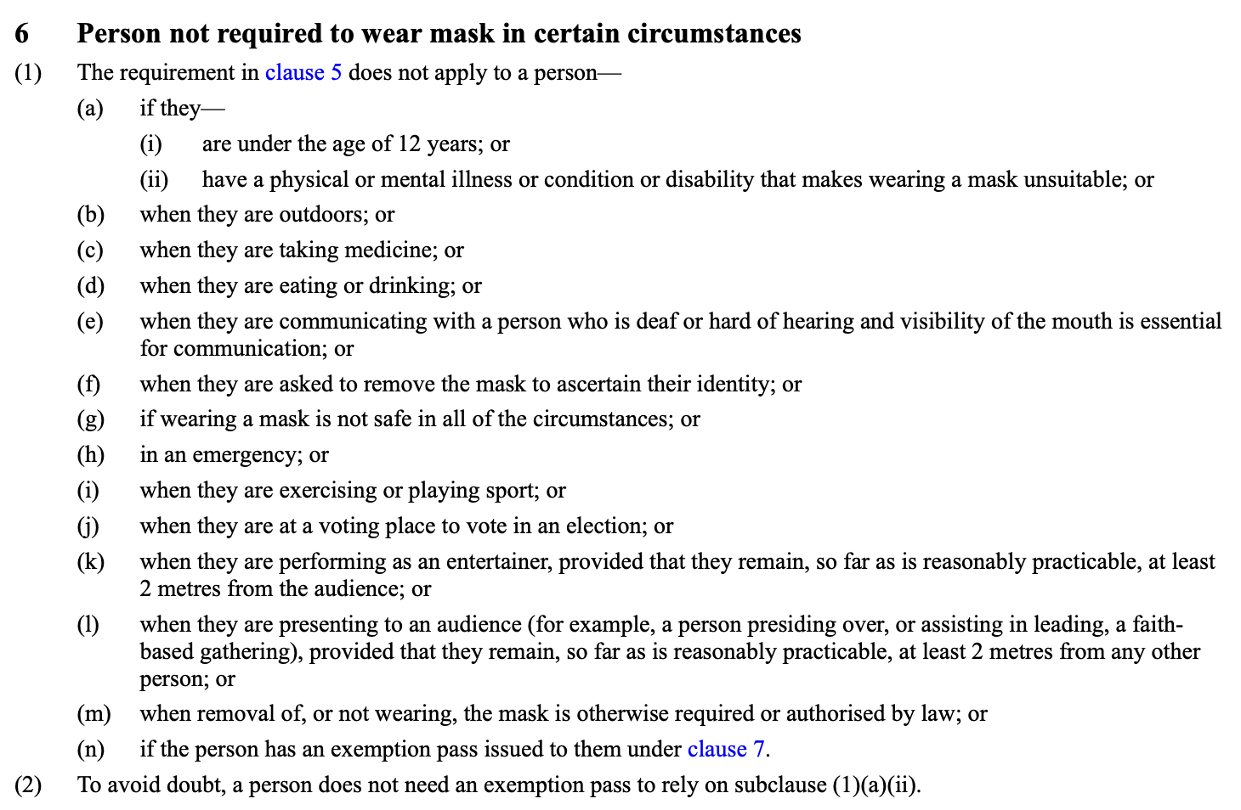
- That means that apart from the other specific circumstances mentioned, a visitor is exempt from wearing a mask if it is not suitable because of a physical or mental illness, condition or disability that they have (clause 6(1)(a)(ii) above), or it is not safe to wear a mask in all of the circumstances (clause 6(1)(g) above).
- The second is a personalised exemption card as granted by the Ministry of Health and recognised in clauses 8 and 9 of the Mask Order.
Exemptions are self-regulating and exemption cards are not a legal requirement
- If a person visiting a health premises has a physical or mental illness or condition or disability that makes a mask unsuitable to wear then they do not need to have a written exemption pass (see clause 6(2)) above – they can chose to have one if they wish to.
- If a person does have a personalised mask exemption pass, then that pass provides conclusive evidence that the holder is exempt under law from wearing a face mask, and should be treated no differently to a person who can wear a mask (clause 7 and 8 of the Mask Order).
- Therefore, it is not a compulsory requirement, and an exemption arises on the valid grounds specified in the Order. If a person does not elect to obtain an exemption card, then you must accept their exemption/s at face-value. It is not for you to consider the validity of the exemption offered.
Laws breached
- Failure to respect a reason for not wearing a mask because of a condition or disability, or where they have a personalised mask exemption pass and to treat a person differently because of that is a breach of the Mask Order.
- Further, it would be a breach of Information Privacy Principle 1 of the Privacy Act 2020 if you asked for details of the customer’s illness, condition or disability. You do not need that information, nor are you entitled to know it.
- It is a fundamental right of every New Zealander to be able to obtain goods and services without discrimination, as codified in the Human Rights Act, which clearly states:
It shall be unlawful for any person who supplies goods, facilities, or services to
the public or to any section of the public—
- to refuse or fail on demand to provide any other person with those goods, facilities, or services; or
- to treat any other person less favourably in connection with the provision of those goods, facilities, or services than would otherwise be the case, by reason of any
of the prohibited grounds of discrimination.

- A failure to observe a patient or visitor's exemption from wearing a mask, which arises out of a disability or condition, is a prohibited ground of discrimination under the Human Rights Act. It is unlawful, and also a breach of the Health and Disability Code. This can give rise to a complaint to the Human Rights Commissioner and/or Health and Disability Commissioner.

Why am I writing to you?
- [Set out the facts that have led to this complaint due to non-compliance with the above mentioned law. Include date(s) and time(s), places, names of persons involved and other relevant circumstances, including circumstances precluding access to goods or services through contactless delivery]
- In circumstances where health services do require patients, workers or residents to wear mask, your failure to supply me with health services because you refuse to acknowledge my exemption is unlawful, as it fails to recognise the exemption based on my disability and/or condition.
- Please advise me, within 48 hours of the date of this letter, as to the steps you will take to remedy your failure to abide by the law and to ensure my rights are observed. If no satisfactory response is received within that timeframe, I reserve my right to pursue legal remedies against your business.

Yours sincerely,
Email: [insert e-mail address]

Clauses 5 of the Mask Order.
Clause 3 of the Mask Order – interpretation of health service premises.
Clause 5(1)(c)(i)-(iii) of the Mask Order.
https://www.legislation.govt.nz/regulation/public/2022/0255/latest/LMS748419.html
Section 44, Human Right Act 1993.
Section 21(1)(h) of the Human Rights Act 1993.
https://www.hdc.org.nz/your-rights/the-code-and-your-rights/

